Group 2: Programinator

Software Development IDE (Programinator)

Version history
0.01 | 11.06.2014 | Document created | Cleo Walker
0.02 | 12.03.2014 | Software Development IDE: Documentation created | Kyle Niemeier
0.03 | 12.15.2014 | Document Finalized | Cleo Walker

Table of Contents

Software Development IDE (Programinator) 1
Documentation 1
Software Development IDE: Introduction & Planning 4
Baseline Project Plan Report 5
1.1. Introduction 5
1.1.1. Project overview- 5
1.2. System Description 5
1.2.1.1. Systems Description- 5
1.3. Feasibility Assessment 5
1.3.1.1. Technical Analysis 5
1.4. Management Issues 5
1.4.1.1. Team Configuration- 5
1.4.1.2. Communication Plan- 5
1.4.1.3. Schedule of Milestones- 6
1.4.1.4. Estimates for phases of the project- 6
Project Scope Statement 7
Software Development IDE: analysis documentation 8
2. Requirements Document 9
2.1. Client Request: 9
2.2. The Environment 9
2.3. User Interaction 9
2.4. The Languages 10
2.5. Testing 10
2.6. File Input/Output 10
2.7. The language Files 10
2.8. The User Files 10
3. Software Development IDE: requirement Specification 11
3.1. Introduction 11
3.2. Scope of the Product 11
3.3. Business Case for the Product 11
3.4. Overview of the Requirements Document 11
4. General Description 11
4.1. Product Functions 11
4.2. User Characteristics 12
5. Specific Requirements 12
5.1. User Requirements 12
5.2. System Requirements 12
5.3. Interface Requirements 12
Software Development IDE: design documentation 13
6. System Design Document 14
6.1. Overview 14
6.2. Introduction 14
6.3. Purpose and Scope 14
6.4. Project Executive Summary 14
6.5. System Overview 14
6.6. Design Constraints 14
6.7. Future Contingencies 14
6.8. Design Flow Charts 15
6.8.1.1.1. Figure 1.0: File Button 15
6.8.1.1.2. Figure 2.0: Variable Button 16
6.8.1.1.3. Figure 3.0: Assignment Button 17
6.8.1.1.4. Figure 4.0: If Button 18
6.8.1.1.5. Figure 5.0: While Button 19
6.8.1.1.6. Figure 6.0: Output Button 20
6.8.1.1.7. Figure 7.0: Input Button 21
6.8.1.1.8. Figure 8.0: Statement Edit 22
7. User Manual 23
1.1 Introduction 23
8. Integration Document 24
8.1. INTRODUCTION 24
8.2. Purpose and Scope 24
8.3. System Overview 24
8.4. System Description 24
8.5. Unit Description 24
8.6. Project References 24
8.7. Glossary 24
8.8. MANAGEMENT OVERVIEW 24
8.9. Description of Integration 24

Group2

Software Development IDE: Introduction & Planning

Baseline Project Plan Report

Introduction

Project overview-

The Software Development Integrated Development Environment (IDE) will be a program intended for introductory programming languages. The program will us a GUI interface. It is not intended for large scale of complex program creation. The main goal of the program is aimed at academic learning and teaching.

System Description

Systems Description-

The IDE will be the typical point and click GUI. Once any given button is clicked various options are given to the user. Input from the user will include filling out text boxes. These represent the placeholders that will be converted into useful information by the program. Once declared and converted, the user can create a simple program based off the input in to the placeholders.

Feasibility Assessment

Technical Analysis

Management Issues

Team Configuration-

Our project work will be separated into classes and further into modules based on the complexity and number of hours they will take. This way, theoretically, no one will work more than another person though in practice it’s impossible to share the load evenly. Our team will be organized as a democratic team with everyone deciding how we will implement each portion of the project. ​

Communication Plan-

Communication between the group and the client will be interviews as well as email. The main channel of storage and communication between members will be GITHUB.com. The group will have a designated repository which all documents can be uploaded, edited, and stored. Email, phone communication, as well as group meetings will also be vital parts of the group’s communication.

Schedule of Milestones-
Milestone | Completed Date Goal
Team members have tasks assigned | 10/15
Working GUI Framework | 11/1
Read Language Definition File | 11/15
Save/load "program file" | 11/20
Test program (AKA: convert to real programming language and run) | 11/20
Final Completion - Submit to Professor | 12/15

Estimates for phases of the project-

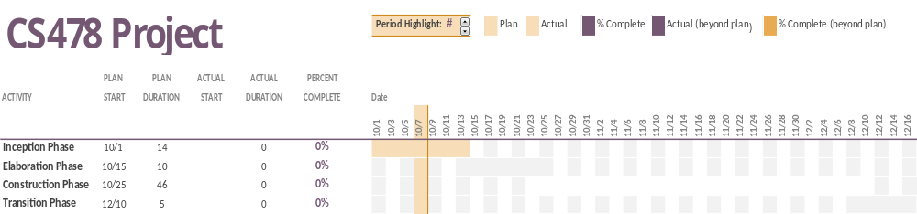

Cs 478 Software Development

Project Scope Statement

General Project Information:

Project Name: Software Development IDE (Programinator)

Project Team: Group 2:
-Darren Miles
-Kyle Niemeier
-Jared Shade
-Nicholas Slow
-Cleodius Walker

Project Objectives:

To enable new computer programming students to easily create programs. This will include creating a GUI style, controlled environment. Enable the student to visually see the logic and semantics of a language without having to worry about syntax.

Project Description:

A new Integrated Development Environment that will inherently be easy to understand and use. The language will be graphical, enabling students to learn easily. The project will follow the Iterative model’s system development life cycle.

Project Deliverables:

Integrated Development Environment System analysis and design
Integrated Development Environment user documentation
SDLC documentation

Duration:

2014 Fall Semester

Group2

Software Development IDE: analysis documentation

Requirements Document

Client Request:
You are to create an Integrated Development Environment (IDE) for and Introductory Programming Language. The language is a graphical language. The development language, operating system, and target language (see Testing) are the developers’ choice, within reason!

The Environment

The environment will be similar to modern IDEs – jGrasp, Visual Studio, etc. It should have a main window for program development, with “appropriate” menu items across the top. Along one side (the right?) will be a list of currently known objects (modules, programs). This list should be kept as a directory structure. These windows may be resized by the user.

There will need to be “pop-up” windows for actions like saving a program, executing a program, etc. The language definition will also necessitate new “pop-up” windows.

User Interaction

The user will not “write” a program in the usual sense. Programming will be accomplished by a set of templates. When a user wishes to use one of the templates, they will indicate this by choosing the template with a “hot key.” For example, an assignment statement may be chosen by “Alt-A”.

Each template will have text to display as well as “spots” for user supplied information. I.e., the statement will be syntactically correct with holes for additional information. In the case of an assignment, the user must supply the expression to calculate and the variable to receive the new value. The assignment might be displayed to the user as:

Calculate ∆ and save the result as ∆

The user would “click” on the appropriate ∆, which would open a window to permit the user to supply the needed information. The first ∆ would require an “expression” and the second ∆ would expect a variable name. Users should be able to minimize/maximize these pop-up windows to make additions/changes. Furthermore a window may be recursive: an IF statement can contain and IF statement, which can contain an IF statement, etc.

Note: ∆ was chosen as a quick display. A better choice might be a “box”.

What templates are available and what elements are parts of the templates are defined by the language in use.

The Languages

A language will be defined for the user (possible chosen by the user). The definition will be in a file (in a known directory). The templates will consist of an appropriate hot key, a name, and the display template. For example:

A, assignment, Calculate ∆ and save the result as ∆

Other elements (like expressions, conditions, etc.) will probably be stored as BNF notation.

Testing

Users can test their program by choosing the appropriate menu item. The user program will then be converted to an actual programming language (developer’s choice), compiled, and executed. The input/output for the user program will be managed by the IDE.

File Input/output

Your IDE will be expected to read in a language definition, and then interacted with the user to create, test, load, save, etc. their programs.

The language Files

Each language file will describe a different language. For now you can think of these different languages as starting with a very simple language (input and output only?) and then additional languages becoming more and more complex.

Each file should consist of the language elements – templates, additional definitions – and rules for conversion to an actual programming language for execution.

The User Files

The user may save/load their creations anywhere available but the current directory is displayed for the user to simply click their choice.

Software Development IDE: requirement Specification

Introduction

This document contains the system requirements for CS478 IDE. These requirements have been derived from several sources, including the class interview, Project2014.docx, and LanguageBasics.docx.

Scope of the Product

This product will be an integrated development environment that will be used as a learning aid for beginner programmers. It will be an interactive environment that will not use a traditional text editor but will use a selection of options to construct a program.

Business Case for the Product

This product is required so Computer Science and Computer Information Systems students will have a learning aid for beginner programming. Students need an environment to learn the basics without needing to learn language specific syntax.

Overview of the Requirements Document

This product will fulfill the following requirements:
- Have a GUI interface
- Allow multiple languages to be defined
- Compile and execute a program
- Have self-contained programs
- Create programs with hotkeys or selections
- Support loading and saving user files

Product Functions

This product will load and save user files, load language definitions, create programs, and compile and execute programs.

User Characteristics

The users of the finished product will be professors and students of Computer Science or Computer Information Systems who are either teaching or learning beginner level programming. The students will not need much experience with programming to be able to use the product to program.

Specific Requirements

This section of the document lists specific requirements for CS478 IDE. Requirements are divided into the following sections:
- User requirements. These are requirements written from the point of view of end users, usually expressed in narrative form.
- System requirements. These are detailed specifications describing the functions the system must be capable of doing.
- Interface requirements. These are requirements about the user interface, which may be expressed as a list, as a narrative, or as images of screen mock-ups.

User Requirements

Users must be able to use hotkeys and/or menu buttons to use features such as open/save a file, load and manage language definitions, create statement templates to be filled in, and compile and execute programs. They must also be able to fill in statement templates and have popup boxes to inform them of errors and actions.

System Requirements

The product will most likely require the system to have the latest version of the .Net runtime installed which it will use both to run the product as well as compile and execute the programs as well as the MSMQ feature.

Interface Requirements

The product will allow users to use hotkeys or menu items to use features and will have resizable panels including an output panel, a list of programs/modules, and an area to view and edit the program (through selecting empty boxes to fill in expressions).

Group2

Software Development IDE: design documentation

System Design Document

Overview

The System Design Document describes the system requirements, operating environment, system and subsystem architecture, files and database design, input formats, output layouts, human-machine interfaces, detailed design, processing logic, and external interfaces.

Introduction

Purpose and Scope

This section provides a brief description of the Systems Design Document’s purpose and scope.

Project Executive Summary

This section provides a description of the project from a management perspective and an overview of the framework within which the conceptual system design was prepared. If appropriate, include the information discussed in the subsequent sections in the summary.

System Overview

This section describes the system in narrative form using non-technical terms. It should provide a high-level system architecture diagram showing a subsystem breakout of the system, if applicable. The high-level system architecture or subsystem diagrams should, if applicable, show interfaces to external systems. Supply a high-level context diagram for the system and subsystems, if applicable. Refer to the requirements trace ability matrix (RTM) in the Functional Requirements Document (FRD), to identify the allocation of the functional requirements into this design document.

Design Constraints

This section describes any constraints in the system design (reference any trade-off analyses conducted such, as resource use versus productivity, or conflicts with other systems) and includes any assumptions made by the project team in developing the system design.

Future Contingencies

This section describes any contingencies that might arise in the design of the system that may change the development direction. Possibilities include lack of interface agreements with outside agencies or unstable architectures at the time this document is produced. Address any possible workarounds or alternative plans.

Design Flow Charts

Figure 1.0: File Button

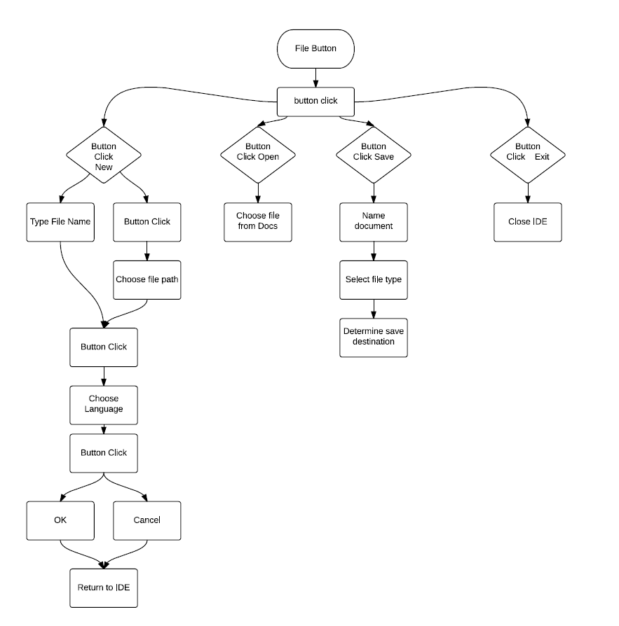

Figure 2.0: Variable Button
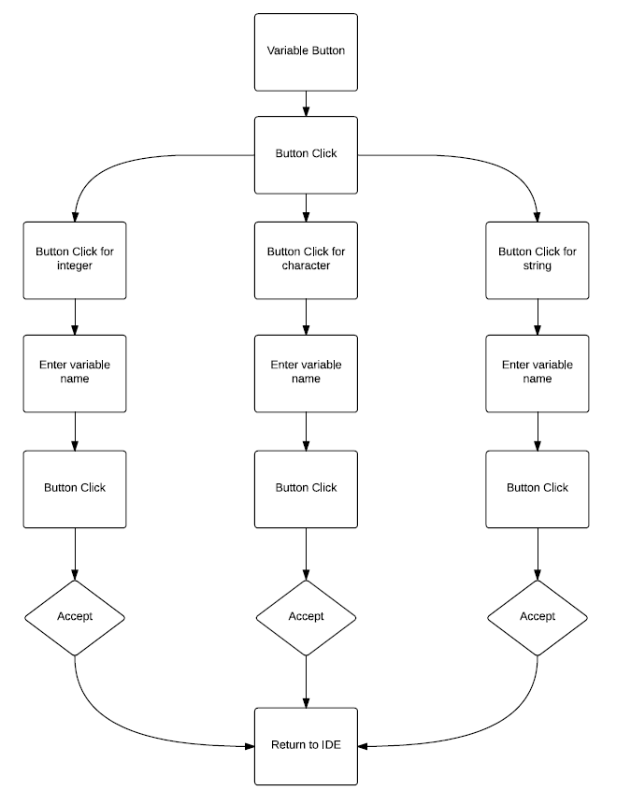

Figure 3.0: Assignment Button
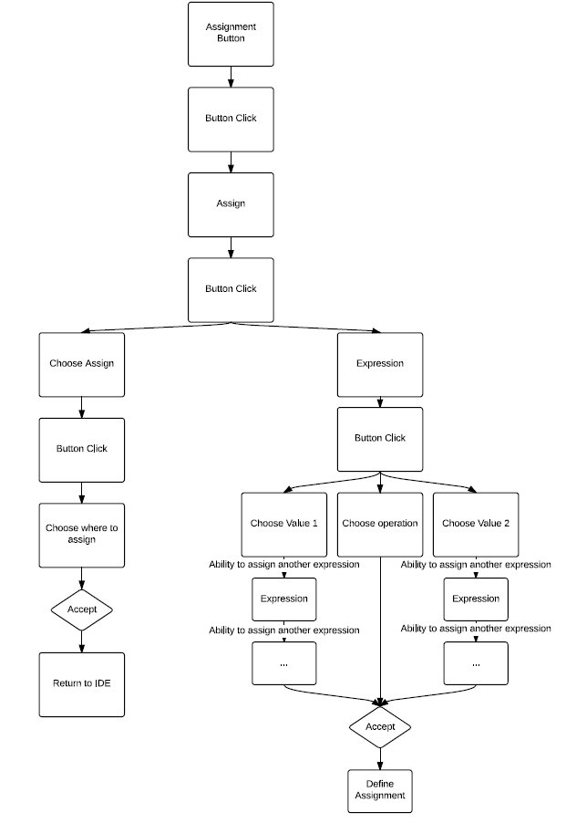

Figure 4.0: If Button

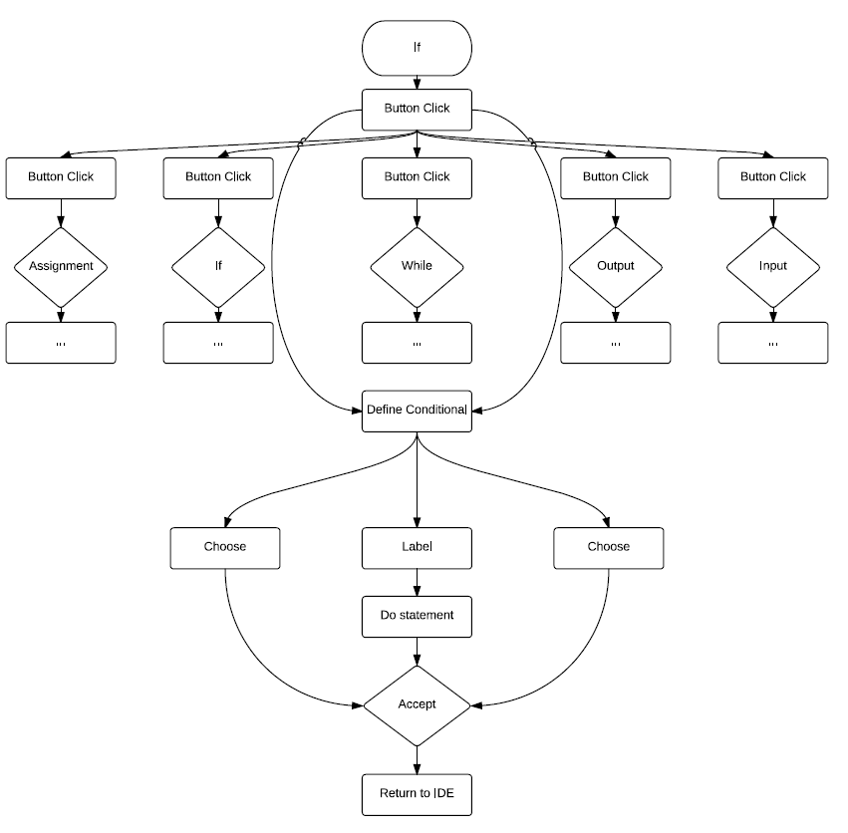

Figure 5.0: While Button

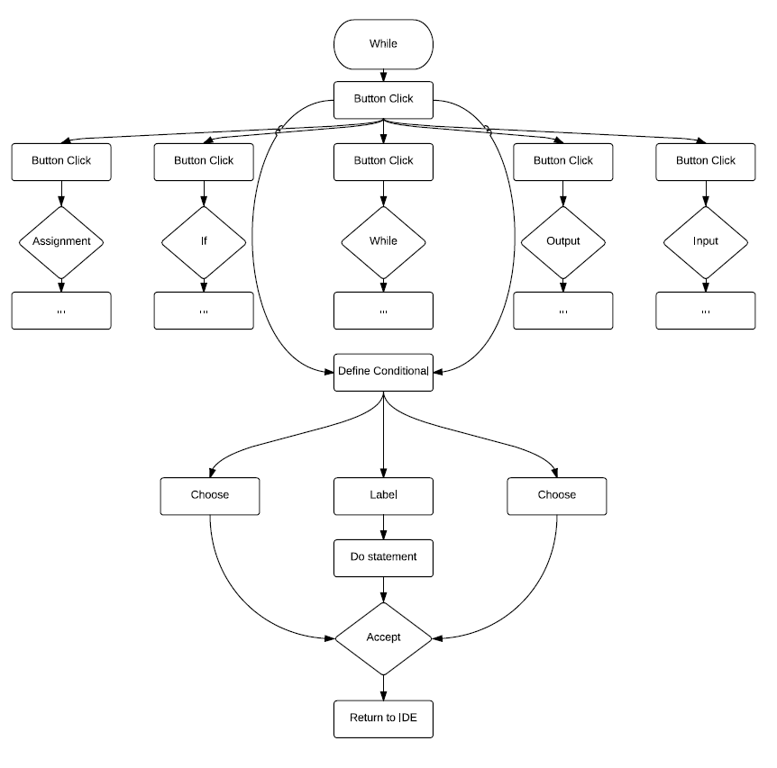

Figure 6.0: Output Button

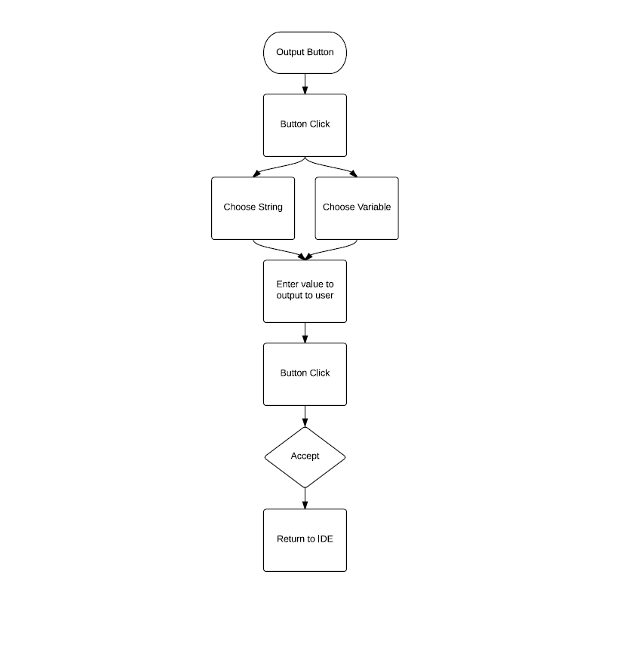

Figure 7.0: Input Button

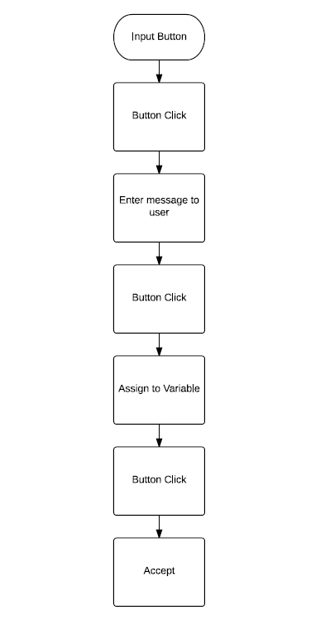

Figure 8.0: Statement Edit

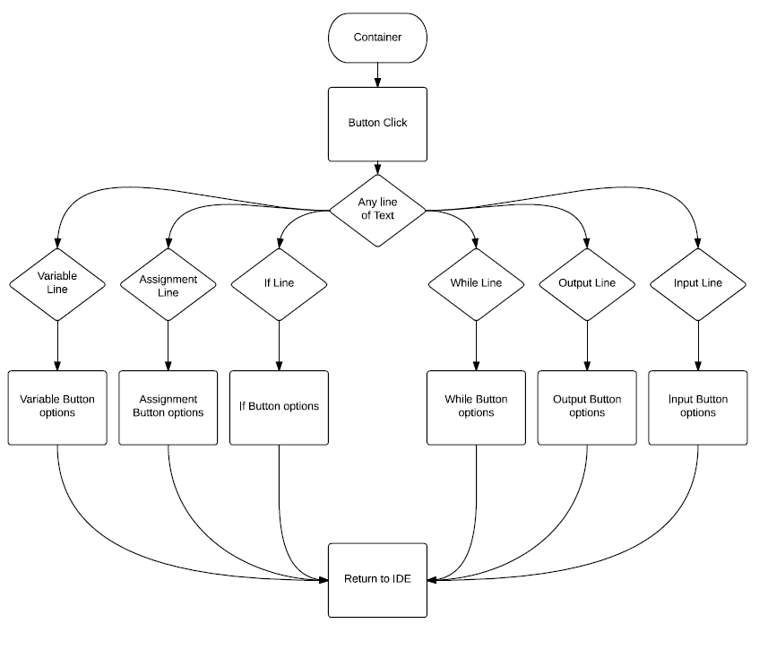

User Manual

Introduction

The User Manual contains all essential information for the user to make full use of the information system. This manual includes a description of the system functions and capabilities, contingencies and alternate modes of operation, and step-by-step procedures for system access and use.

Purpose and Scope
This section provides a description of the purpose and scope of the User Manual. (TO BE COMPLETED)

Integration Document

The integration document defines the activities necessary to integrate the software units and software components into the software item. The integration document contains an overview of tile system, a brief description of the major tasks involved in the integration, the overall resources needed to support the integration effort. The plan is developed during the Development Phase and is updated during the Integration and Test Phase; the final version is provided in the Implementation Phase.

INTRODUCTION
This section provides an overview of the information system and includes any additional information that may be appropriate.

System Overview
This section provides a brief overview of tile system to he integrated, including a description of the system and its organization. Describe the environment/infrastructure and how this unit or system will integrate into it. Include any risk involved and the mitigating procedures to reduce or eliminate that risk.

System Description
This section provides an overview of tile processes the system is intended to support. If the system is a database or an information system, provide a general discussion of the description of the type of data maintained and the operational sources and uses of those data. Also include all interfaces to other units or systems.

Unit Description
This section provides an overview of the processes the unit (or module) is intended to support. If more than one unit is being integrated, provide descriptions of each unit in this section.

